Soft count Automation

Step 1: Open outlook 2016 and press alt + F11 to run vba

Step 2: Every time need to update chklist folder in skumar@suncommobile outlook mail to update

Mail contents , run the softcount_mail_update module to get chklist folder , in chklist folder click Send /Receive and select update folder

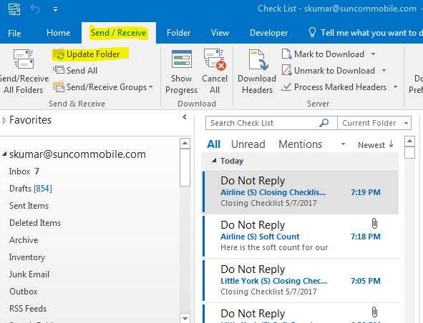

Step 3: Then run the soft count module to save the mail lists and attachments in specific folder and document.

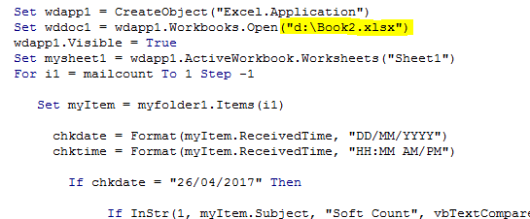

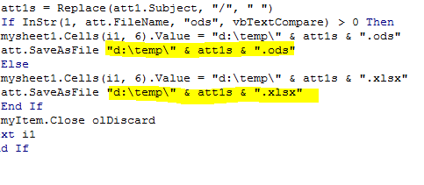

Step 4: Close the outlook, outlook VBA editor save book2.xlsx , again open the book2.xlsx and press Alt + F11 and open the VBA Editor and run softcount module

It creates new workbook and paste formatted values from downloaded documents, then opens RQ4 soft count downloaded sheet and compare values from pivot tables

Step 5: check the sheet has NA values and blank details , if sheet has NA values then manually check the pivot table values

Step 6: Save automated workbook and close it , again open that workbook in order to get one sheet output

By run softcount_onesheet_output

Soft count Status Automation

Step 1: Open outlook 2016 and press alt + F11 to run vba

Step 2: Every time need to update chklist folder in skumar@suncommobile outlook mail to update

Mail contents , run the softcount_mail_update module to get chklist folder , in chklist folder click Send /Receive and select update folder



Step 3: Then run the soft count module to save the mail lists save the book and close it

Step 4: Again open the book which has previously opened and run the soft count modeule befor that check the below highlighted values are proper values

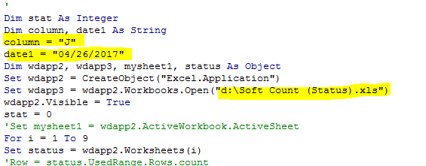

Step 5: The book “D:\Soft Count (Status).xls” contains the result.